1. **Setting Arduino**
2. **Setting Preferences (File – Preferences)**

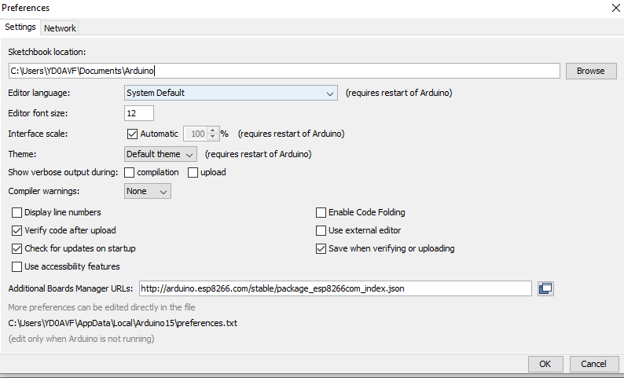

1. **Setting Board (Tools – Board – ESP8266 Boards – NodeMCU 1.0)**

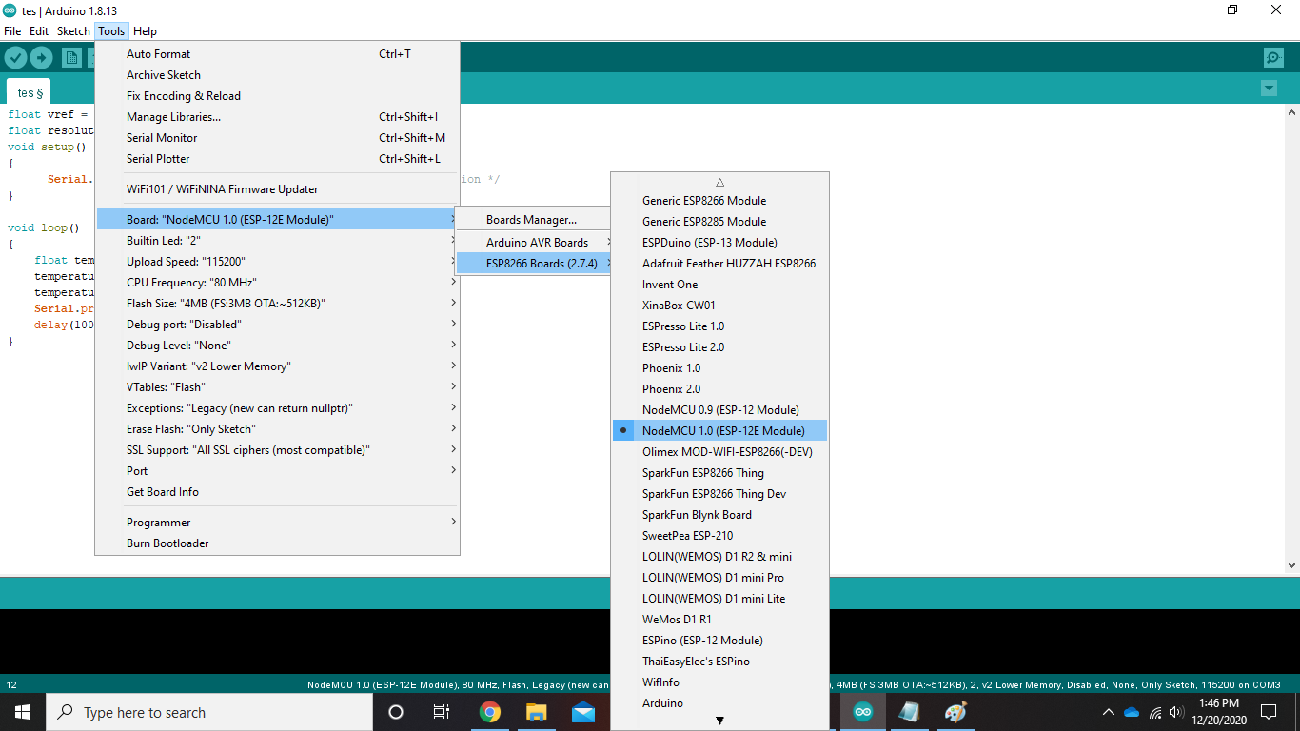

1. **Setting Upload Speed (Tools – Upload Speed – 115200)**

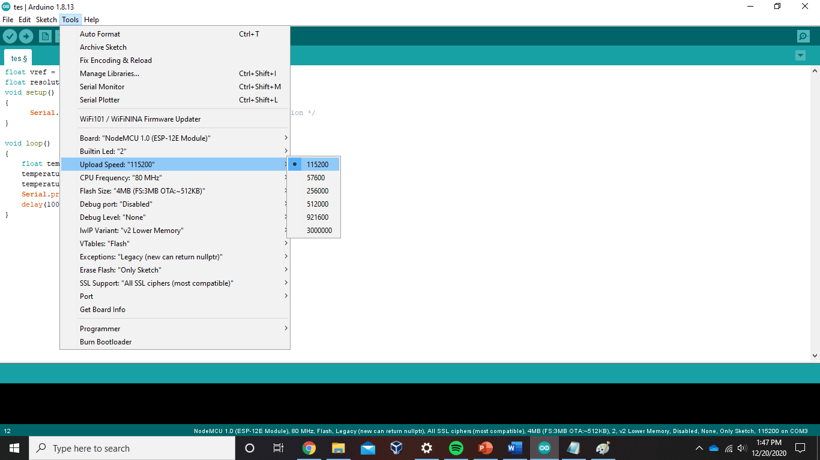

1. **Setting Flash Size (Tools – Flash Size – 4MB FS:3MB OTA:~512KB)**

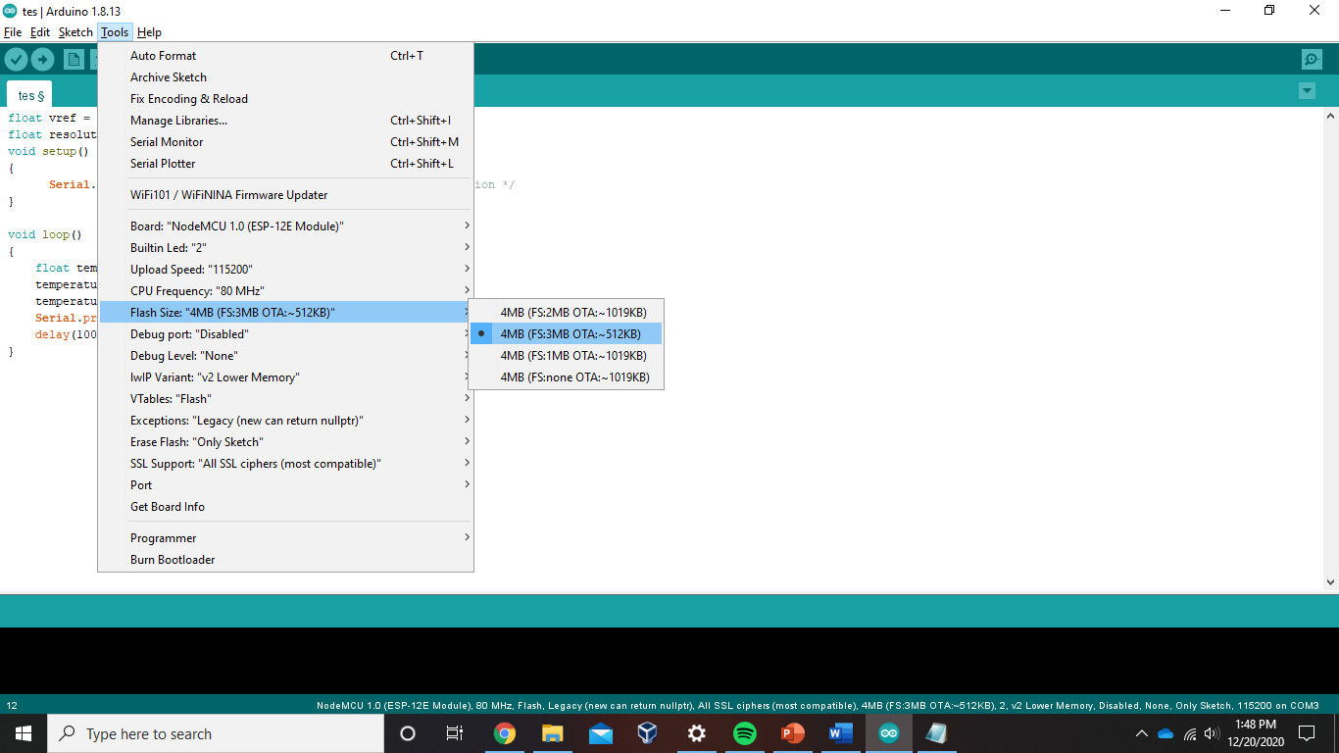

1. **Setting Libraries (Tools – Manage Libraries…)**

* 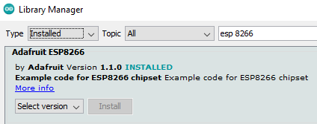**Install Library Board of Adafruit ESP8266**
* 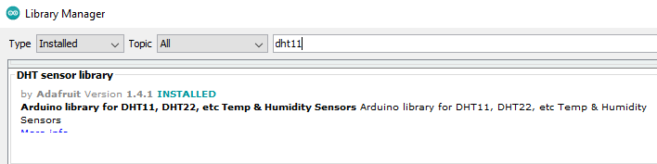**Install Library of DHT sensor library**

1. **Sensor Temperature LM35**

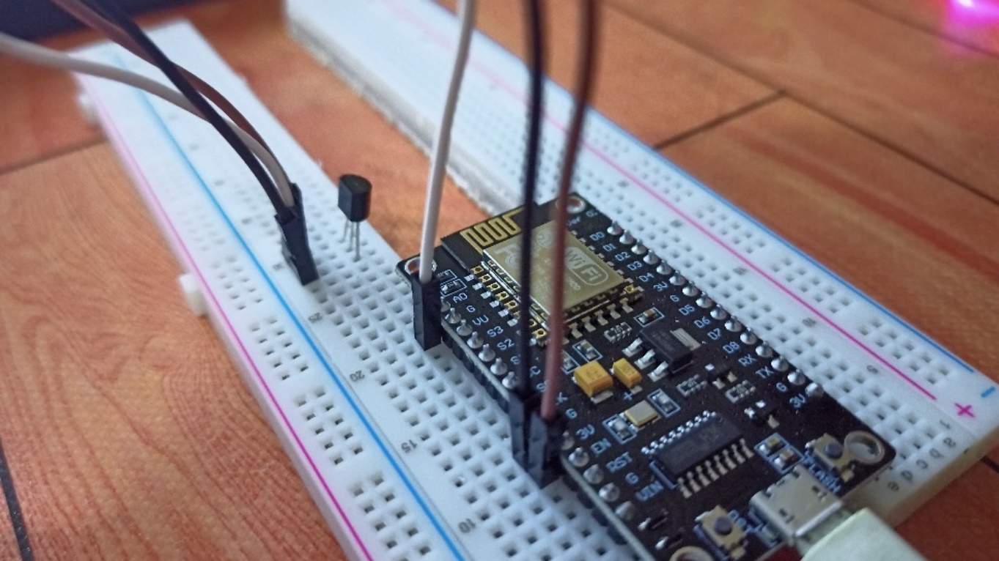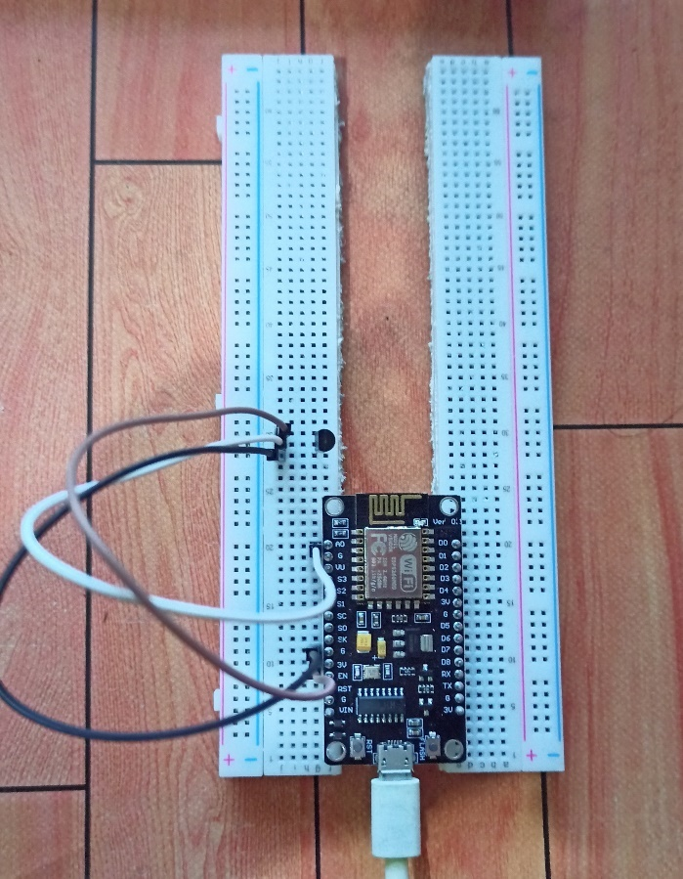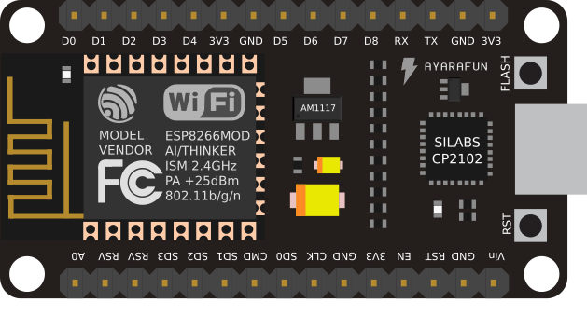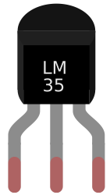

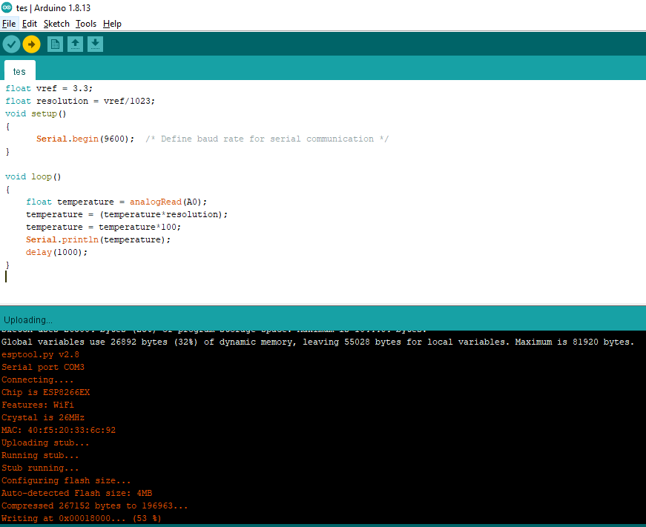

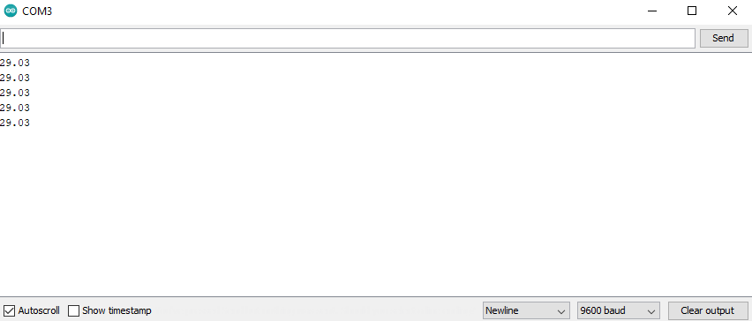

1. **Sensor Humidity DHT11**

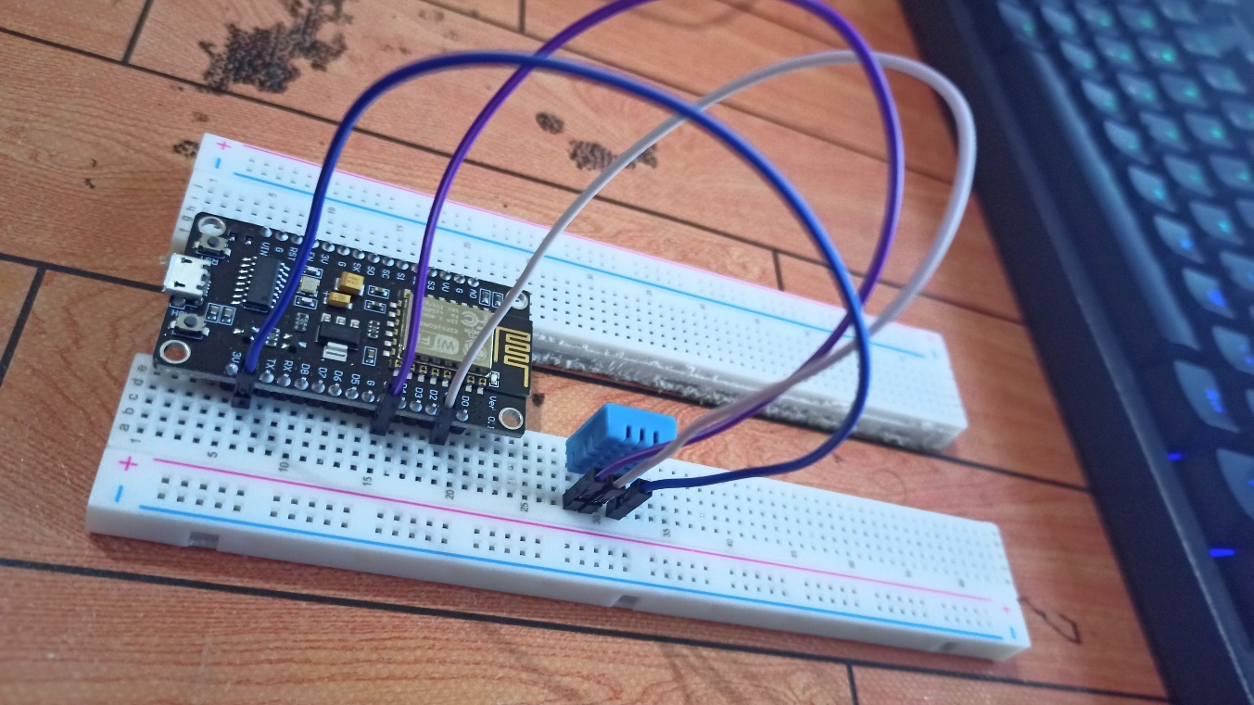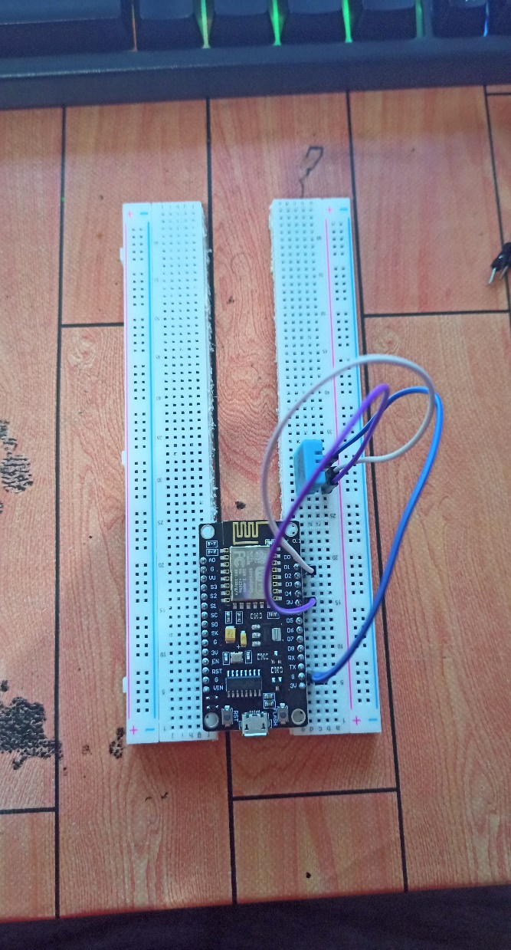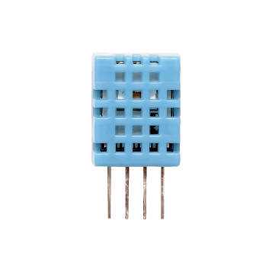

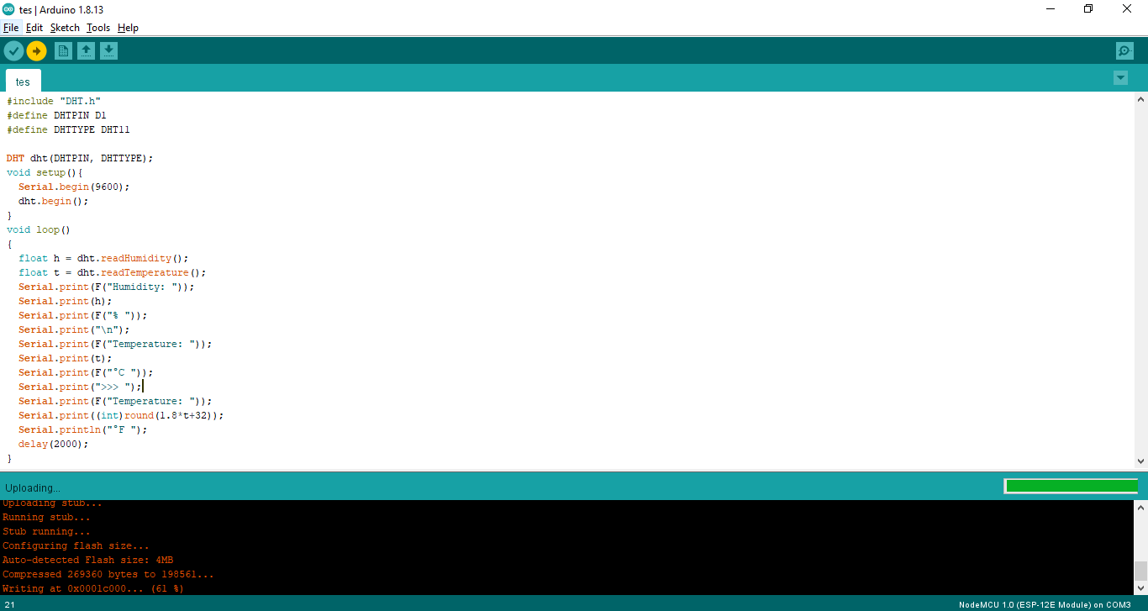

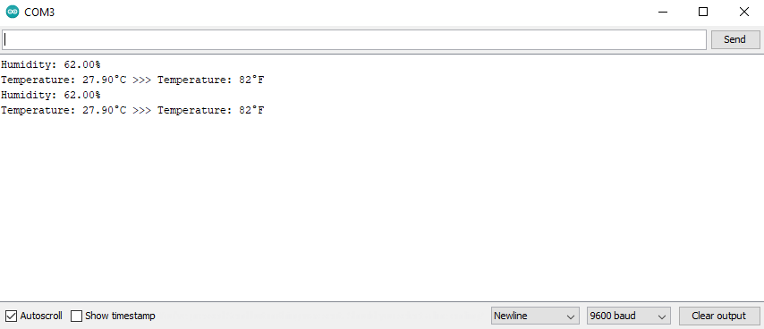

#include "DHT.h"#define DHTPIN D1#define DHTTYPE DHT11DHT dht(DHTPIN, DHTTYPE);float vref = 3.3;float res = vref/1023;void setup(){ Serial.begin(9600); dht.begin();}void loop(){ Serial.println(" ====== DHT11 SENSOR ====== "); float hum = dht.readHumidity(); float tem = dht.readTemperature(); Serial.print(" Humidity DHT11: "); Serial.print(hum); Serial.print("% "); Serial.print("\n"); Serial.print(" Temperature DHT11: "); Serial.print(tem); Serial.print("°C "); Serial.print(">>> "); Serial.print((int)round(1.8*tem+32)); Serial.println("°F "); Serial.println(" ====== LM35 SENSOR ====== "); float temp = analogRead(A0); temp = (temp*res); temp = temp*100; Serial.print(" Temperature LM35: "); Serial.print(temp);

Serial.println("°C ");

Serial.println(" ========================== ");

delay(10000); //waiting for 10 seconds

}

**BLYNK**

#define BLYNK_PRINT Serial

#include <BlynkSimpleEsp8266.h>

#include <SPI.h>

#include <ESP8266WiFi.h>

#include "DHT.h"

char auth[] = "S6kgpOckbJWevYez5Rxrr2kKcLAw5SXj";

char ssid[] = "Azzam";

char pass[] = "azzam53a";

#define DHTPIN D1

#define DHTTYPE DHT11

DHT dht(DHTPIN, DHTTYPE);

SimpleTimer timer;

float vref = 3.3;

float res = vref/1023;

void sendSensor()

{

float hum = dht.readHumidity();

float tem = dht.readTemperature(); // or dht.readTemperature(true) for Fahrenheit

if (isnan(hum) || isnan(tem)) {

Serial.println("Failed to read from DHT sensor!");

return;

}

// You can send any value at any time.

// Please don't send more that 10 values per second.

Blynk.virtualWrite(V5, tem);

Blynk.virtualWrite(V6, hum);

}

void setup(){

Serial.begin(9600);

Blynk.begin(auth, ssid, pass);

dht.begin();

timer.setInterval(1000L, sendSensor);

}

void loop()

{

Serial.println(" ====== DHT11 SENSOR ====== ");

float hum = dht.readHumidity();

float tem = dht.readTemperature();

Serial.print(" Humidity DHT11: ");

Serial.print(hum);

Serial.print("% ");

Serial.print("\n");

Serial.print(" Temperature DHT11: ");

Serial.print(tem);

Serial.print("°C ");

Serial.print(">>> ");

Serial.print((int)round(1.8*tem+32));

Serial.println("°F ");

Serial.println(" ====== LM35 SENSOR ====== ");

float temp = analogRead(A0);

temp = (temp*res);

temp = temp*100;

Serial.print(" Temperature LM35: ");

Serial.print(temp);

Serial.println("°C ");

Serial.println(" ========================== ");

Blynk.run();

timer.run();

delay(10000); //waiting for 10 seconds

}

Reference:

Power Point - E2. Microcontroller_NodeMCU

<https://medium.com/@andreanewgate/menggunakan-sensor-suhu-dan-kelembapan-dht11-dengan-nodemcu-b7976f527583>

<https://forum.arduino.cc/index.php?topic=171299.0>

<http://kursuselektronikaku.blogspot.com/2019/10/iot-project-blynk-nodemcu-esp8266.html>

<https://kelasrobot.com/solved-cara-mengatasi-error-login-timeout-blynk/>